Name:____________________________________________________________
Address:__________________________________________________________
City:___________________State:__________________Zip:___________________
Telephone:______________________Email:_____________________________

Please check if this is a gift 
If this is a gift, please give name and address to send the Certificate of Ownership:

Name:______________________________Address:__________________________
City:________________________ State:______Zip:___________

Choose One:
Dark Brick lining inside square $200.00 
Light Brick outside square $125.00 

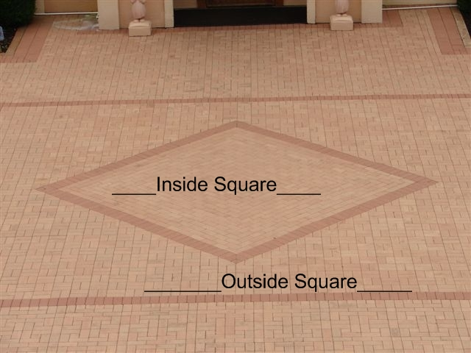

Please print name or message, as it is to appear on the brick.
Each brick can include up to three lines of engraving with up to 18 characters per line.
Print only one character (letter, number, punctuation mark, or space) per square above. (Symbols not permitted)

Examples:
In Memory Of = 12 spaces
Jane S. Doe = 11 spaces
1900 - 2000 = 11 spaces

 Centered
Payment: Check one
Cash 
Check  Check#________
Charge Type:_____________#________________________________Exp._____
Signature:_____________________________________Date:__________________

Thank you for supporting the Precious Moments Chapel

The Chapel Engraved Brick Program

Thank you for your interest in ordering a personalized brick for the Precious Moments Chapel Memorial Plaza. Your donation for this brick enables the Precious Moments Foundation to ensure continuance of free Chapel tours and provide the care and maintenance of the Chapel and the grounds. Your gifted brick will serve as a lasting tribute to our Precious Moments family and friends and serve as a gentle reminder of the founder and artist, Samuel J. Butcher’s mission to glorify God with his artistic gifts.

The Chapel Engraved Brick Program is the perfect way to leave a blessing of remembrance and celebration for you, your family and friends. These bricks also make a great gift for that “hard to buy for person” that has everything. We will send a Certificate of Ownership for each brick to you or the person you designate.

Your gifted brick will be installed in the Memorial Plaza, directly in front of the Chapel. You will have two options of purchase. Option number one is priced at $200.00 per brick and will be engraved on a dark colored brick which will border the center square. Option number two is priced at $125.00 per brick and will be engraved on a light colored brick outside the center square. If multiple bricks are ordered, they will be placed together if requested.

How to make your brick purchase:
Please complete the order form and mail with your payment to:
Precious Moments Foundation
Engraved Brick Program
4321 Chapel Road
Carthage, MO 64836

Call or visit the Precious Moments Gift Shoppe in Carthage, MO (800-543-7975 ext. 2869)

The Precious Moments Foundation is a non-profit 501(c)(3) organization. A receipt for tax purposes is provided upon request.

- Brick placement will be based on a first-come, first-served basis in a timely fashion upon receiving the completed order form, weather permitting. No exceptions. Notification of the installment of the brick will be given as soon as possible upon completion. Brick placement may take up to 6 months.

- The Precious Moments Foundation reserves the right to determine the proper placement of each brick for aesthetic reasons. The Precious Moments Foundation also reserves the right to prohibit the engraving and placement of any bricks deemed inappropriate, without notice, as determined by the Precious Moments Foundation in its sole discretion and decision.

Precious Moments Foundation
4321 Chapel Road, Carthage, MO 64836
Chapel@PreciousMomentsChapel.org

